Silly Sort

UVA Online Judge

DASALGO Problem Code: SRT3 Status: Accepted

UVA Problem 1016 – Silly Sort Runtime: 0.045 seconds

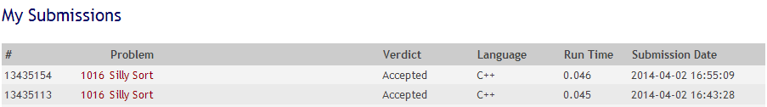

(Source code with comments at the last page)

Discussion

The problem is, given an array with unsorted elements, given that each swap would cost the sum of the 2 elements’ values; find the minimal cost to sort the sequence of the array.

First, get the lowest possible sum for sorting the array, we must switch the lowest with the element that was supposed to be in the lowest index. If the lowest is already at the right index, it will find the next lowest switch. However, there are cases in which the lowest may not be used, but when used, the sum is lower than that of the next lowest. Therefore, we would need to replace the lowest with the next lowest to see whether the values that would come out is higher or lower.

Another way to explain it is this. Since only two elements can be swapped at a time, all of the elements that are not in the right array index should be swapped. Therefore, all of them should be added up. The next question is which one is our constant swapper? The answer is the lowest value in the array that is not in the right position.

In the end, the sum would be the all elements of the array that are not in the right index and the number of times the lowest value is used.

However, there are special cases in which the lowest value is not used, but when used produces a sum lower than that of the lowest wrong-indexed value. Therefore, we would have to "borrow" it so that it can be used as a replacement for the swapping.

We faced minor problems during the submission of the code, we always exceeded the time limit and some of our java programs would not even compile nor run when submitted to the online judge. We solved this by looking of a c++ version of our code, edited out some redundant variables, applied some of our code into it, and added some comments for the explanations of each block of code.

References

"I solved a problem." : Silly Sort (Spoj. N.p., n.d. Web. 2 Apr. 2014. <http://isolvedaproblem.blogspot.com/2012/02/sillysort.html>.